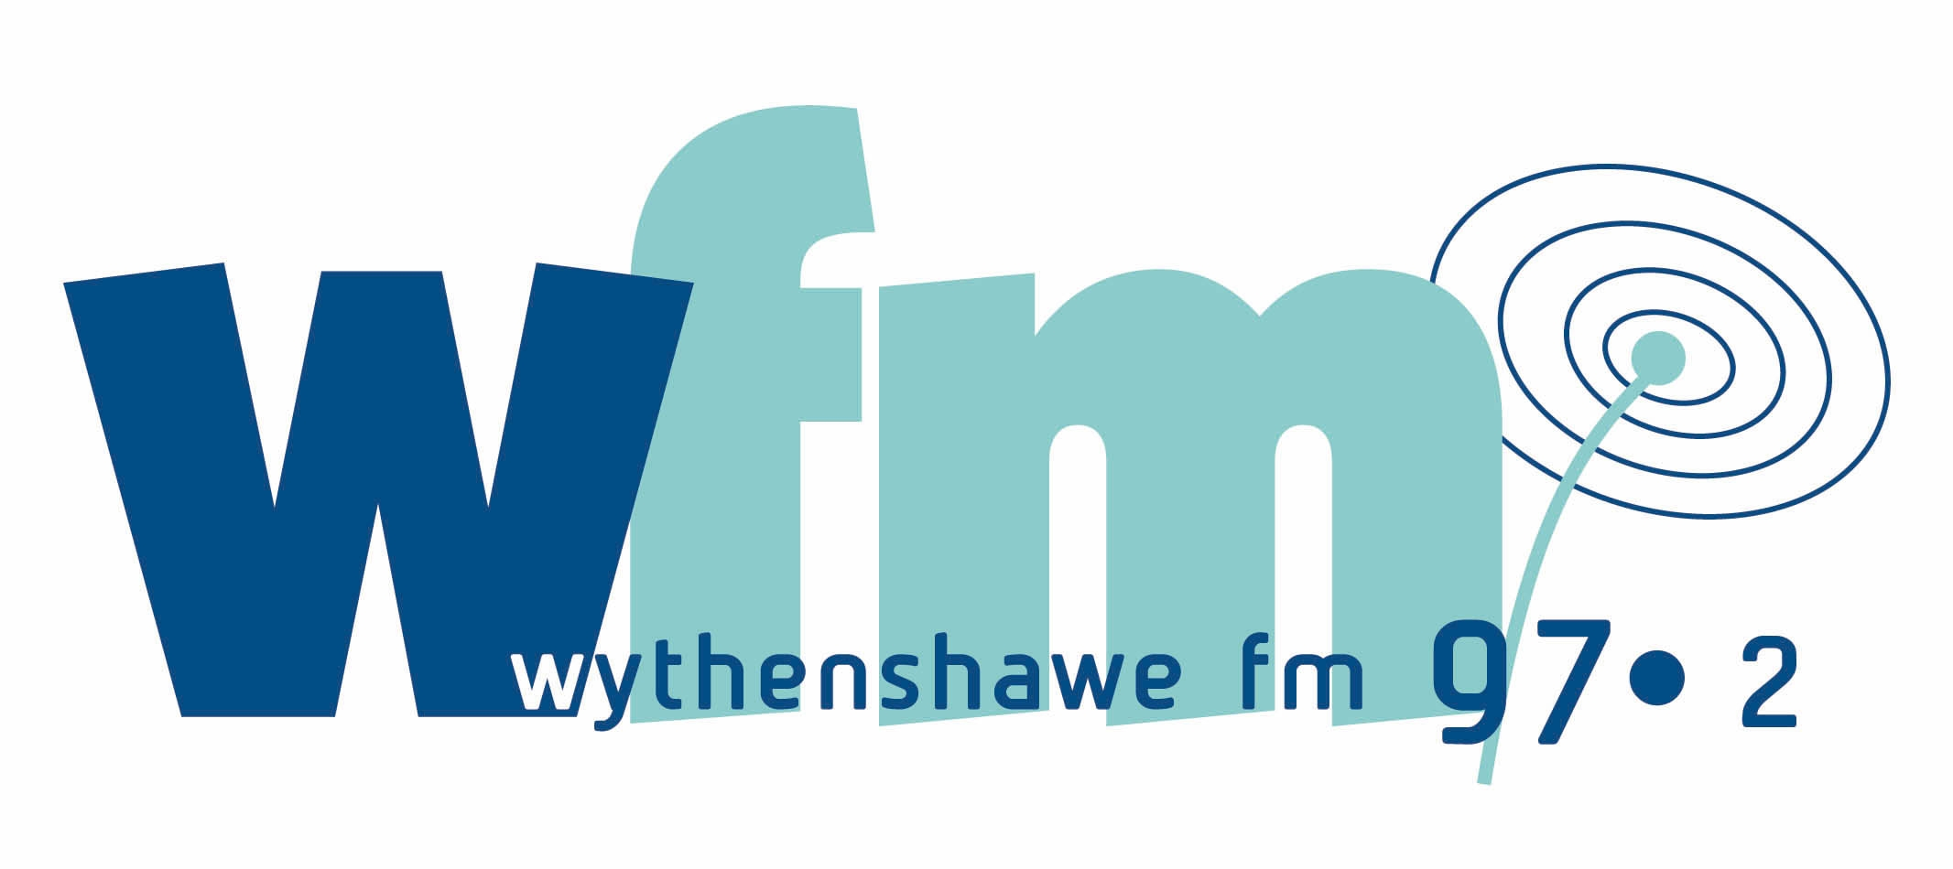

Volunteer Agreement

Part 1. The Organisation

Volunteers are an important and valued part of Wythenshawe FM and we hope that you enjoy volunteering with us and feel part of our team.

This Agreement tells you what you can expect from us, and what we hope for from you. We aim to be flexible so please let us know if you have any comments or specific requirements, and we will do our best to accommodate them.

This agreement seeks to strike a balance between doing our best for you as a valued volunteer and our need – as the licence holders of a full-time radio station – to run a full schedule of programming for the benefit of Wythenshawe.

We, Wythenshawe FM, will do our best to:

- introduce you to how the organisation works and your role within it
- provide you with relevant training that you may need
- provide regular meetings with your line manager so that you can tell us if you are happy with how your work is organised and get feedback from us. If a meeting isn’t possible then we will ensure mechanisms are in place that ensure you are able to get your views across.
- respect your skills, dignity and individual wishes and do our best to meet them
- pay your travel and meal costs, if you live in M22 or M23 postcode areas
- consult with you and keep you informed of possible changes to your role at the station
- insure you against injury you suffer or cause due to negligence
- provide you with a safe workplace
- apply our Equal Opportunities Policy
- apply our Disciplinary Procedure if there is a problem
- include new volunteers in appropriate activities

Part 2. The Volunteer

Wythenshawe FM volunteers agree to do their best to:

- work reliably and to the best of my ability, and to give as much warning as possible whenever I cannot work when expected
- follow the ground rules that are set out in this Agreement
- adhere to any other station policies (e.g. Equal Opportunities, Health & Safety) *
- understand that being offered a show on Wythenshawe FM is a privilege and not a right and that Radio Regen reserves the right to withdraw such an offer at any time
- stick to the Ofcom Broadcasting Code and the laws that cover broadcasting such as libel and contempt of court

* Wythenshawe FM’s policies are currently under review. Copies of each policy will be made available to volunteers as they are finalised.

Part 3. Ground Rules

In order to balance the needs of the station and its staff with those of the volunteer, basic guidelines are set out below. Be aware that your actions as a volunteer at the station have an impact on the running of Wythenshawe FM as a whole.

Please remember that being offered a show on Wythenshawe FM is a privilege and not a right. The station is here to serve the whole community and as such we offer 6 months volunteering at the station per volunteer. There will be times when we will not be able to offer show slots beyond this period. The station has a duty to include new volunteers and try to give anyone in the community a chance to present and/or work on their own show.

Failure to follow the rules outlined below may result in the Disciplinary Procedure being invoked.

Please see the Disciplinary Procedure set out in the Volunteer Passport.

3. 1 Minor Issues

- Volunteers must sign in and out every time they are at Wythenshawe FM

Reason: This is both a health and safety requirement and a requirement for funding. If volunteers fail to sign in, there may be financial implications for the station.

- Volunteers must ensure that all guests sign in and out and stick to the station rules. All actions by your guests, including signing in, are your responsibility.

Reason: This is both a health and safety requirement and a requirement for funding. If volunteers fail to sign in, there may be financial implications for the station.

- Volunteers must inform Wythenshawe FM staff if inviting guests onto a show

Reason: Outside office hours we need to make sure that security are aware who is coming in. Sometimes the door downstairs is locked and security will only buzz in people on the list – this makes the building safer for you.

- Volunteers must inform Wythenshawe FM staff as early as possible if they cannot make a show. If it is not possible to speak to a staff member Leave a message on 0161 499 7982.

Reason: To enable staff to make other arrangements regarding the schedule and to book other volunteers in if possible.

- Volunteers must not jump into “spare” slots in the schedule without prior permission from Wythenshawe FM station staff

Reason: To ensure that no volunteer dominates the schedule and to ensure a variety of music styles are played throughout the broadcast schedule.

- Volunteers must not volunteer or be present at the station for more than 15 hours per week

Reason: This rule is in place to prevent burn out of volunteers and to ensure that the facilities are available for all who wish to use them.

- Volunteers must not use their programmes as a platform for their views alone

Reason: Whilst the station is a place for Wythenshawe people to have a voice, Ofcom requires us as broadcasters to be impartial and balanced in the views that we represent.

3.2 Serious Misconduct

- Volunteers must not smoke anywhere within Wythenshawe FM or Alderman Gatley House including the studio, training room, corridors, kitchen and toilets

Reason: Since July 1st 2007, it is against the law to smoke in a workplace such as Wythenshawe FM. This is in accordance with the Smokefree (Premises and Enforcement) Regulations 2006.

- Volunteers must not drink alcohol anywhere within Wythenshawe FM or Alderman Gatley House including the studio, training room, corridors and toilet

Reason: This forms part of Wythenshawe FM’s agreement with the Building Managers Redman Heenan, and a breach of this agreement could have serious implications regarding Wythenshawe FM’s tenancy at Alderman Gatley House. Also, a broadcaster under the influence of alcohol is not a responsible broadcaster.

- Volunteers must treat the building security guards and all other building staff with respect

Reason: The building managers are very supportive of the station, for example by allowing Wythenshawe FM to extend our schedule into the evening, and it is in everyone’s best interest to ensure that this flexible, supportive relationship is maintained.

- Volunteers must not misrepresent their status at Wythenshawe FM, and should be proud that they are a volunteer

Reason:

Internally - to prevent an abuse of power and to ensure that experienced volunteers cannot take advantage of newer volunteers.

Externally - to ensure that the trustees of the charity Radio Regen (Wythenshawe FM is part of Radio Regen) are not misrepresented and to minimise confusion of roles within Wythenshawe FM.

- Volunteers must follow Wythenshawe’s broadcasting guidelines (set out in your training materials), the Ofcom Broadcasting Code, and the law as it relates to radio programmes e.g. libel, contempt of court, incitement etc

Reason: If you don’t, you may be breaking the law and the station could be taken off air. Please see a member of staff it you need a copy of Wythenshawe FM’s broadcasting guidelines.

- Volunteers must not make comments that encourage violence or are disrespectful towards people on the basis of their ethnicity, gender, sexual orientation, religion, political belief, national origin, race or marital status.

Wythenshawe FM aims to promote equal opportunities for all and believes that everyone deserves to be treated with respect, including volunteers, staff and listeners.

- Volunteers must not undertake to train new volunteers at the station

Reason: To ensure that the correct training is given to new volunteers. Volunteers may become mentors after they have completed their 40 hours of training, but this can only take place with the agreement of a member of Wythenshawe FM staff.

- Volunteers must arrive at the station 15-30 minutes before the start time of any show they are presenting or producing

Reason: In order to present or produce a good show you need to be prepared. Wythenshawe FM staff need to know that you are here before the show starts and you need time to check that the equipment you are using is in good working order and that you have any scripts you need and are prepared for interviews and community read outs.

- Keep all areas of Wythenshawe FM tidy. Wash cups if you use them and clean up after yourself in the shared public areas of the building including the toilets and corridors.

Reason: Wythenshawe FM staff do not have time to spend clearing up after volunteers. Wythenshawe FM is a community facility which should be respected.

- Volunteers must play community and other adverts when asked to by staff at Wythenshawe FM

Reason: Organisations and companies that advertise on Wythenshawe FM provide much needed income for the station.

- Volunteers must not sign out a piece of Wythenshawe FM equipment and then lend it to someone else.

Reason: Volunteers are responsible for any equipment which is signed out by them, including loss and damage. Wythenshawe FM reserves the right to fine volunteers for lost or damaged equipment.

- All volunteers must act in an honest and transparent manner at all times.

Reason: Wythenshawe FM operates to a standard of honesty which all staff, volunteers and participants are required to adhere to.

3.3 Gross Misconduct

- Volunteers must not obstruct the surveillance camera in the studio

Reason: The camera is there to protect volunteers and staff members and to ensure that station rules are adhered to when staff are not present.

- Volunteers must not come to the station when intoxicated (this includes alcohol and drugs)

Reason: If inebriated, a volunteer will not be in an acceptable state to either produce or present a show, or to work alongside other volunteers or staff.

- Volunteers must not take illegal drugs in the station

Reason: It is illegal.

- Volunteers must not threaten, bully, intimidate or harass (verbally, sexually, physically, or by other means) anyone on the premises. Harassment may include paying people an unreasonable amount of attention.

Reason: Behaviour of this kind is anti-social and inappropriate. If a volunteer has any issue or concern regarding another volunteer or a member of staff this should be discussed in confidence with an appropriate member of staff.

- Volunteers must not use Wythenshawe FM’s internet, email or phone for personal purposes or otherwise inappropriately. Inappropriate use includes accessing pornographic, violent or other offensive material. Staff should be consulted if any downloads need to be made or if the internet, email or phone need to be used for personal reasons.

Reason: Usage of all of the above is monitored at Wythenshawe FM in accordance with Radio Regen’s IT Policy. Excessive use of these facilities results in a drain on Wythenshawe FM’s resources. Accessing inappropriate material may cause offence to other staff or volunteers and may be illegal.

Part 4. Other volunteer responsibilities

As a community minded volunteer at Wythenshawe FM you should:

- Do your best to attend Wythenshawe FM Volunteer Meetings
- Prepare your show and produce the best radio broadcast you can
- Remember that the priority of Wythenshawe FM is to broadcast to the community in Wythenshawe and always keep this in mind when planning your shows
- Help to raise the opinion of Wythenshawe among residents and those listening outside of the area. This doesn’t mean that you can’t criticise things about Wythenshawe if this is justified, but remember that part of the aim of Wythenshawe FM is to promote pride in the area, which will in turn help to make it a better place!

Part 5. Your agreement

I have read, understand and agree to adhere to all of the above. I understand that any breach of this agreement may result in Wythenshawe FM’s Disciplinary Procedure being invoked.

I understand that an incident of Gross Misconduct may result in the Disciplinary Procedure being invoked and suspension from volunteering at the station until any hearing takes place.

Signed by volunteer: _____________________

Print Name: _____________________

Date: _____________________

Signed by your manager at
Wythenshawe FM: _____________________

Print Name: _____________________

Date: _____________________

Note that this agreement is in honour only and is not intended to be a legally binding contract of employment.

